EUGLOH Summer School
Lasers is Medicine and Life Sciences (LAMELIS)
11th – 15th July 2022
Organised by University of Szeged (Hungary)
with the participation of invited speakers from partner institutions and the member universities of the EUGLOH alliance:
Ludwig-Maximilians-Universität München (Germany)
Lund University (Sweden)
Universidade do Porto (Portugal)
Université Paris-Saclay (France)

WHAT CAN YOU LEARN?
Lectures, interactive discussion sessions and teamwork from distinguished experts of the field provide comprehensive overview of the basic theoretical background and practical applications of lasers in medicine and life sciences.
Since lasers revolutionised additive manufacturing, state-of the art developments in 3D printing technologies with a primary focus on application in life sciences are also covered.
Discussion and dissemination the implications of these developments in a broad sense, including industrial, social and legislative perspectives.
Participating students are trained by live streaming or video courses in different topics related to the development of transversal skills:
- Basic theory and operation of lasers
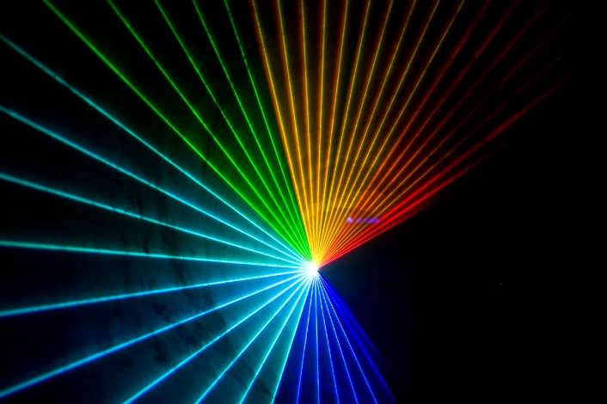

- Basics of optics
- Classification of lasers
- Lasers in medical imaging
- Lasers in therapy
- Laser-assisted manufacturing
- Lasers in perspectives:
  - Economic
  - Social
  - Government
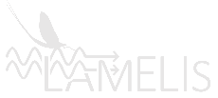
  - Industry
  - Legislative
- Additive manufacturing, 3D printing

WHO IS THE TARGET AUDIENCE?
Although the depth of talks is tailored for students in life sciences, the summer school is open to students from all faculties interested in the theoretical background and practical implementation of lasers in life sciences.
Bachelor, master and PhD students from all faculties of the partner universities of the EUGLOH alliance (University of Szeged, Université Paris-Saclay, Lund University, Ludwig-Maximilians-Universität München, Universidade do Porto). No special background knowledge is required. School is also open for junior and senior scientists of the participating universities.

WHAT PEDAGOGICAL METHODS/TOOLS ARE APPLIED?
Lectures by online video streaming, interactive communication tools, teamwork, networking.

HOW ATTENDENCE IS AWARDED?
EUGLOH Certificate and 4 ECTS will be provided for the students attending the school.

WHERE ARE THE LECTURERS FROM?
University of Szeged and partner institutions:
- Ferenc Bari, Department of Medical Physics and Informatics, University of Szeged
- Zsolt Geretovszky, Department of Optics and Quantum Electronics, University of Szeged
- Katalin Varjú, Katalin Hideghéty, Extreme Light Infrastructure - Attosecond Light Pulse Source (ELI-ALPS)
- Petar H. Lambrev, Biological Research Centre, Szeged
- Justin E. Molloy, Francis Crick Institute, UK
- Martin Leahy, National University of Ireland, Galway, IE
- Jörg Pawelke, Technische Universität and Helmholtz-Zentrum Dresden, DE
- Adrian Podoleanu, University of Kent, UK
- Tomáš Čižmár, Friedrich-Schiller-Universität, Jena, DE
Ludwig-Maximilians-Universität München
- Ronald Sroka Laser- and Immunologie-Forschungs-Einrichtungen at the Klinikum der Universität München
Lund University
- Sune Svanberg, Atomic Physics Division of the Lund Institute of Technology
University of Porto
- Helder Manuel Paiva Rebelo Cerejo Crespo, Department of Metallurgical and
Materials Engineering
Université Paris-Saclay
- Gerard Baldacchino, IRAMIS "Saclay Institute of Matter and Radiation"

WHERE CAN YOU GET INFORMATION?
General information: eugloh@rekt.szte.hu
Academic programme:
Prof. Ferenc Peták, Department of Medical Physics and Informatics, University of Szeged (EUGLOH, academic leader of Work Package for Research and Innovation), petak.ferenc@med.u-szeged.hu
Prof. Ferenc Bari, Department of Medical Physics and Informatics, University of Szeged (LAMELIS, lead organiser), bari.ferenc@med.u-szeged.hu
Administrative support: Eszter Sasi-Pokriva, sasi-pokriva.eszter@med.u-szeged.hu

Registration
https://modulo.etr.u-szeged.hu/Modulo2/default/en/invitation/94cc42ef-5d7b-4cf0-b83b-4b0041442dd9
Registration deadline: 24th June

